Realtime Transaction Processing at scale

**Task1 : Install Chocolatey**

1. Open Power shell as administrator and run the below command.

**Get-ExecutionPolicy**

1. Run below command to install.

Set-ExecutionPolicy Bypass -Scope Process -Force; [System.Net.ServicePointManager]::SecurityProtocol = [System.Net.ServicePointManager]::SecurityProtocol -bor 3072; iex ((New-Object System.Net.WebClient).DownloadString('https://community.chocolatey.org/install.ps1'))

## **Task 2 :** Install kubernetes-helm

1. Oen Power shell as administrator and run below command to install Helm.

**choco install kubernetes-helm**

## Task 1: Install Python

1. Open your browser, navigate to the address bar, type or paste the following URL: <https://www.python.org/>, then press the **Enter** button.

1. In the **Python** window, select the **Downloads** tab, then click on **Python 3.12.1** or later version.

1. **python-3.12.1-amd64.exe** file will be downloaded. Click on the downloaded file to install the Python software.

1. In the **Install Python 3.12.1 (64-bit)** window, tick the checkbox **Add python.exe to PATH** option before installation (Python must be in the PATH environment variable). Then, click on **Customize installation**.

1. Leave the **Optional Features** window in the default state and click on the **Next** button.

1. In the **Advanced Options** window, tick the checkbox **Install Python 3.11 for all users** and then click on the **Install** button. If you see the dialog box - **Do you want to allow this app to make changes to your device?** then click on the **Yes** button.

1. In **Setup was successful** window, click on the **Close** button. You have successfully installed the Python software.

1. In your windows search bar, type **Command Prompt**. In the **Command Prompt App** dialog box, navigate and click on **Run as administrator**. If you see the dialog box - **Do you want to allow this app to make changes to your device?** then click on the **Yes** button.

1. Python was installed in C:\Program Files\Python311 (refer step #6). Therefore, you need to change the current directory to the **Program Files** directory (The command used to move back to the previous directory is **cd .. [space after cd then two dots],** the command used to move to the next directory is **cd <name of the directory>)**
2. Move into the folder where the Python was installed and run the **pip** command.

Copy

cd Program Files

Copy

pip

copy

python -m pip install --upgrade pip

**Task 4 : Install .NET SDK 8.**

1. Open your browser, navigate to the address bar, type or paste the following URL: <https://dotnet.microsoft.com/en-us/download/dotnet/thank-you/sdk-8.0.101-windows-x64-installer> then press the **Enter** button.
2. File will be downloaded. Click on the downloaded file to install

1. Click on **Install**.

1. Once the installation is successful, click on **Close**.

**Task 5 : Install Node JS.**

1. Open your browser, navigate to the address bar, type or paste the following URL: [Node.js — Download (nodejs.org)](https://nodejs.org/en/download) then press the **Enter** button.
2. Click on the **Windows Installer**

1. File will be downloaded. Click on the downloaded file to install

1. Click on Next.

1. Accept the terms and click on Next.

1. Keep the default location and click Next.

1. Click Next

1. Select the checkbox and then click Next.

1. Click on Install.

1. After installation ,click Finish.

**Task 6 : Install Visual Studio Code.**

1. Open your browser and Navigate to the <https://visualstudio.microsoft.com/downloads/>
2. Drop down the **Free download** and select **Windows x64 User Installer**

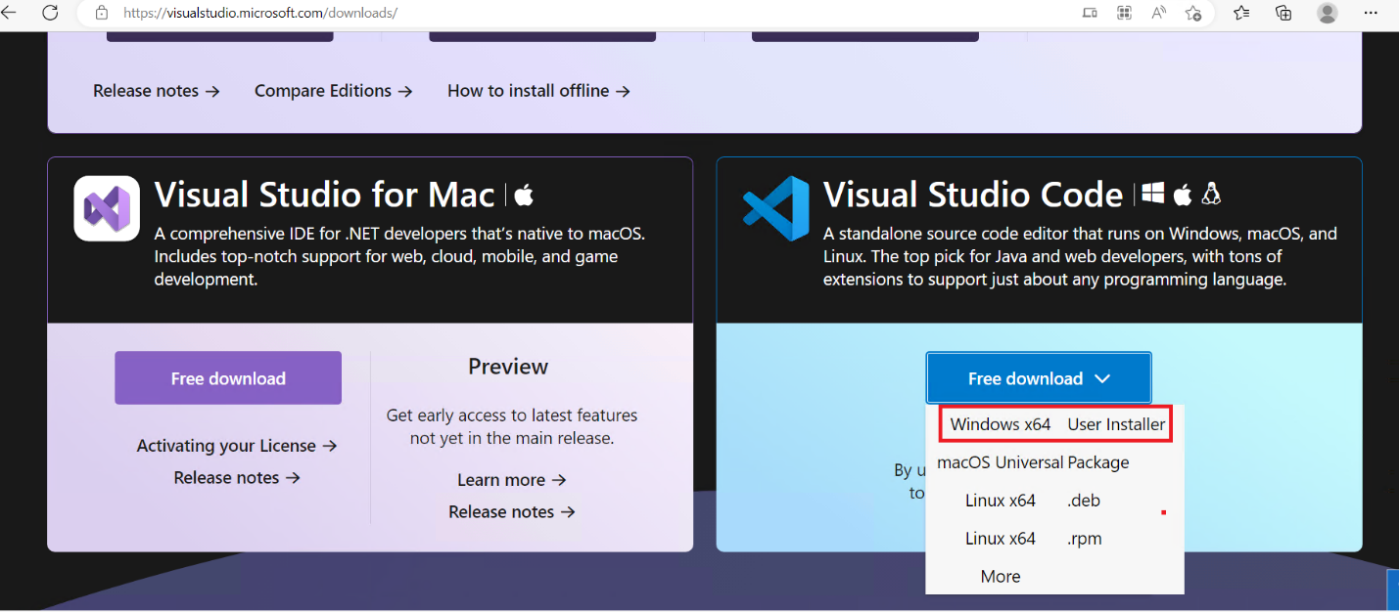

1. Run and install downloaded file

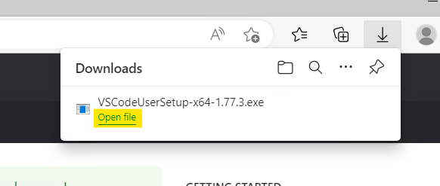

1. Select **I accept the agreement** and select **Next**.

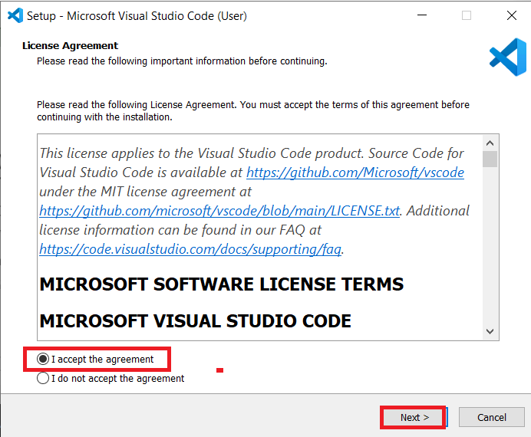

1. Select the location where should install Visual Studio and then select **Next**

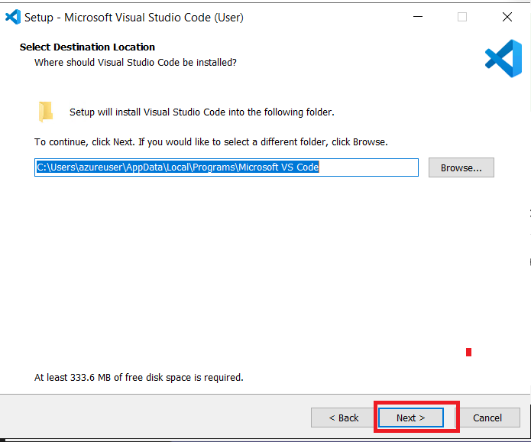

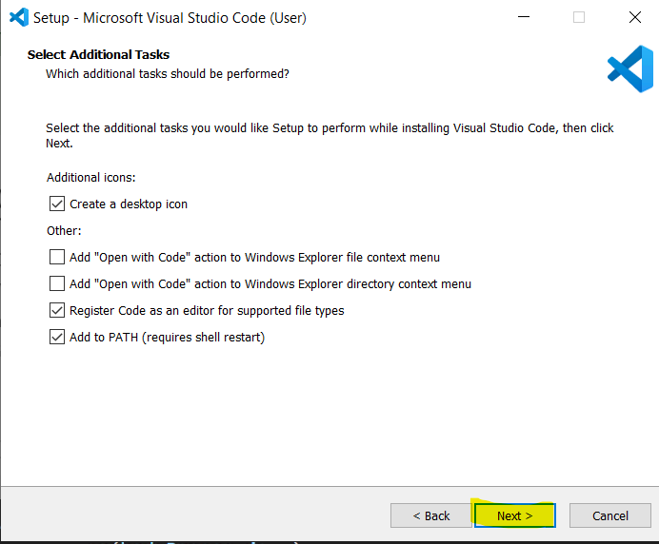

1. Click **Install**

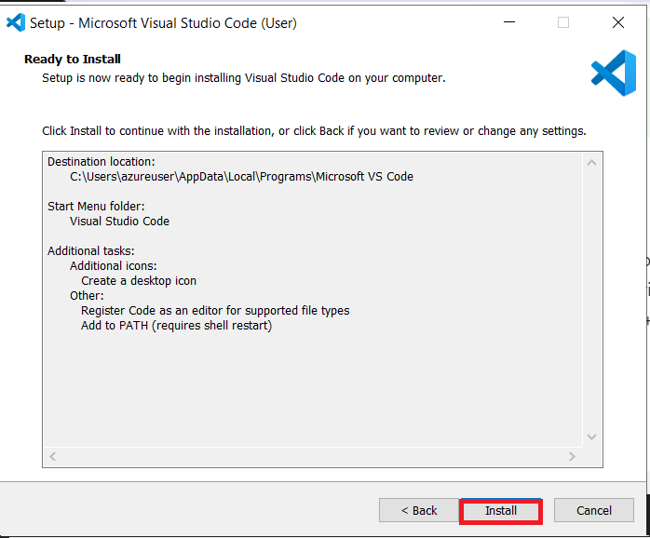

## Task 7 : Install GitGit

1. Download and install from [git-scm.com/downloads](https://git-scm.com/downloads).
2. Follow the instructions to install it.

## Task 8: Azure CLI

1. Open your browser, navigate to the address bar, type or paste the following URL: <https://learn.microsoft.com/en-us/cli/azure/install-azure-cli-windows?tabs=azure-cli>, then press the **Enter** button.
2. In the **Install Azure CLI on Windows** window, select the **Downloads** tab, then click on **Latest release of the Azure CLI(64-bit)** or later version.

1. File will be downloaded. Click on the downloaded file to install

1. Click on I accept the terms check box and then click on **Install**.

1. Click on **Finish**.

**Task 10: Istall nvm**

1. Open your browser, navigate to the address bar, type or paste the following URL: <https://github.com/coreybutler/nvm-windows/releases> then press the **Enter** button.
2. Click on the **nvm-setup.exe.**

1. File will be downloaded. Click on the downloaded file to install

1. On the Setup-NVM for Windows tab select the **I accept the agreement** and click on **Next** button

1. Select the path and click on **Next** button

1. On ready to install tab , click on Install button.

## Task 11: Install Helm and set the Path

1. Open your browser, navigate to the address bar, type or paste the following URL: <https://github.com/helm/helm/releases> then press the **Enter** button.
2. File will be downloaded. Click on the downloaded file to install

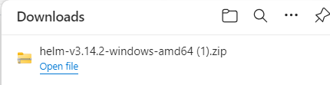

1. Extract the folder copy and past into Program files folder in C drive

1. Copy the helm path

1. Open the run command by pressing **Windows + R** and type **sysdm.cpl** and hit enter, this command will open the System Properties Window.

1. Under System Properties, click on the **Advanced** tab, and click on**Environment Variables.**

1. Under User Variables, click on **Path** and click on **Edit** button.

1. In the **Edit environment variable** ,select **New** and past the **helm path**.Click on **Ok** button

1. Under System Variables, select **Path** and click on **Edit** button

1. In the **Edit environment variable** ,select **New** and past the **helm path**.Click on **Ok** button

1. In Environment variable tab click on Ok button

1. On the System Properties tab , click on **Apply** and select Ok button.

## Task 12: Update App Installer

1. Click on the following link: <https://aka.ms/getwingetpreview> , open the downloaded file and click on the **Update** button to **Update App Installer**.

## Task 13 : Install VisualStudio

1. Open your browser, navigate to the address bar, type or paste the following URL: <https://visualstudio.microsoft.com/downloads/> then press the **Enter** button.
2. Click on Free download from Community

1. File will be downloaded. Click on the downloaded file to install

1. Click on **Continue.**

1. Under the web & cloud click the check boxes of **ASP.NET and web development , Azure development,Python development** and **Node.js** Click on **Install**.

1. Close the window once done.

## Task 14: Docker Installation

1. Open your browser, navigate to the address bar, type or paste the following URL: <https://docs.docker.com/desktop/install/windows-install/> then press the **Enter** button.
2. Click on the **Docker Desktop for Windows**.

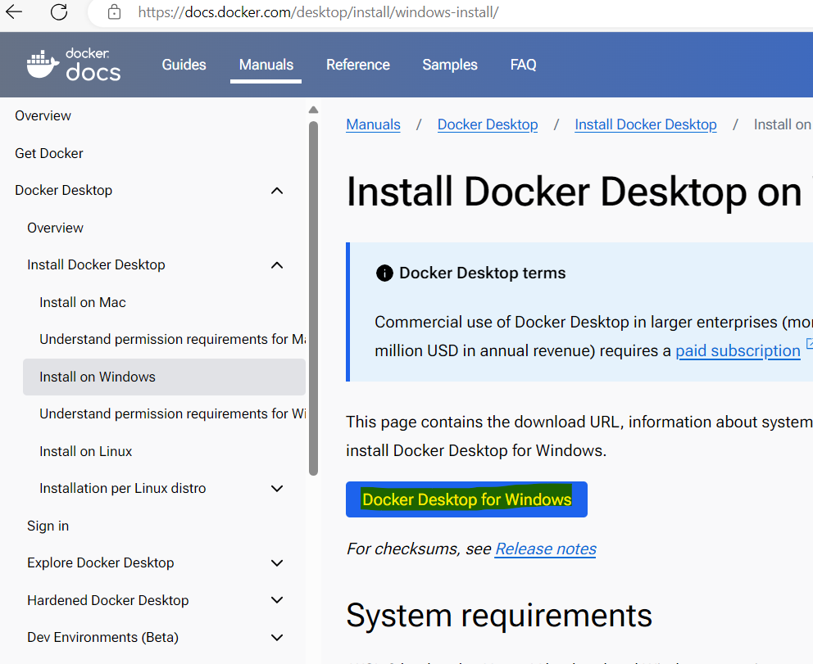

1. File will be downloaded. Click on the downloaded file to install

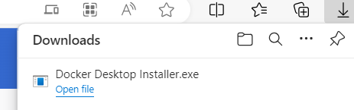

## **Task 15 : Install** [**Git CLI**](https://git-scm.com/downloads)

1. Navigate to [https://git-scm.com/download/win](https://git-scm.com/download/win%20) and download for windows.

2. Run and install the downloaded file.

**

## **Task 16: Install function cli**

1. Open your browser, navigate to the address bar, type or paste the following URL: <https://learn.microsoft.com/en-us/azure/azure-functions/functions-run-local?tabs=windows%2Cisolated-process%2Cnode-v4%2Cpython-v2%2Chttp-trigger%2Ccontainer-apps&pivots=programming-language-csharp>, then press the **Enter** button.
2. In the **Develop Azure Functions locally using Core Tools** window, select the **Downloads** tab, then click on **v4.x-windows64-bit** or later version.

1. File will be downloaded. Click on the downloaded file to install

1. Click on **Next** and select the check box to **accept the license** in the next step and click on **Next**.

1. Click on Next and then **Install** in the next screen.

1. Click on **Finish** once done.

